Barwick and Stoford CP School

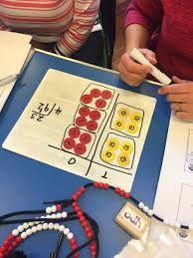

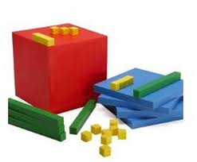Calculation Policy 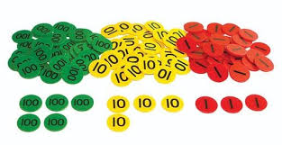
Summer 2024

At Barwick and Stoford CP School, the aim of the calculation policy is to ensure that the school’s approach to teaching maths is consistent throughout. Therefore, as the child progresses through school, the approaches to different calculations are familiar and are then further improved upon through recollection and repetition of the methods used in previous years. With additional methods being taught as required by the topic.

This policy has been compiled and adapted from White Rose Maths guidance, as this is the maths scheme that we follow as a whole school, including our attached pre-school.

This policy provides details for:
- Addition
- Subtraction
- Multiplication (Times Tables)
- Multiplication (Calculations)
- Division

Each of the above operations are broken down into which skills are required, and will be taught, for each year group. It also shows recommended models and visuals to be used which support the teaching and understanding of the concepts within each section.

Jack’s Pre-school
The Counting Principles
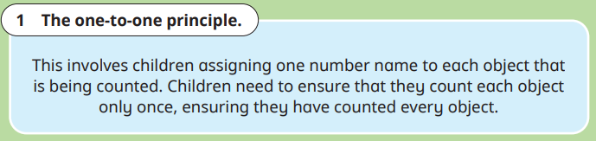
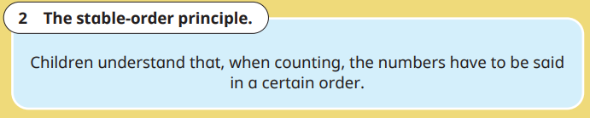
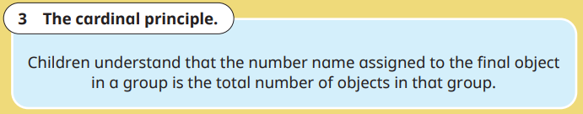
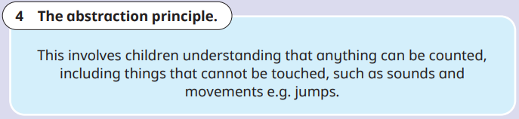
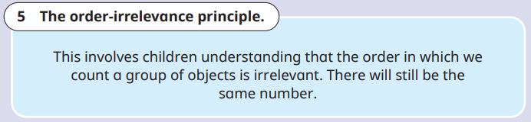

EYFS
Vocabulary
Part, whole, add, more, plus, and, make, altogether, total, equal to, equals, double, most, count on.
equal to, take, take away, less, minus, subtract, leaves, difference between, how many more, how many fewer / less than, most, least, count back, how many left, how much less is_?

Addition | Subtraction | Multiplication and Division  (Counting in groups and sharing)
Children are encouraged to gain a sense of the number system using concrete objects to count.  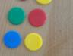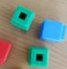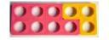 | Children are encouraged to gain a sense of the number system using concrete objects to count. | Children use concrete objects to make and count equal groups of objects.  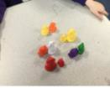
Children combine objects in practical ways and count them.  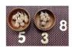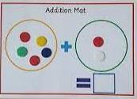 | Children understand subtraction as counting out from a group.  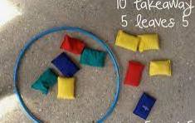 | Children use concrete objects to count and share equally into 2 groups. They understand this as halving or dividing by 2.  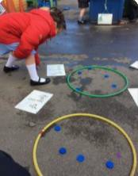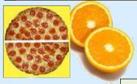
Children understand addition as counting on. They will count on in ones using objects, cubes, bead strings and number lines.  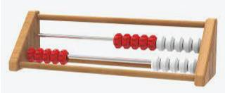  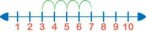 | Children begin to count back in ones using objects, cubes, bead string and number lines.  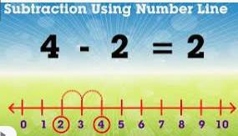 | Children understand doubling as repeated addition. 2 + 2 = 4  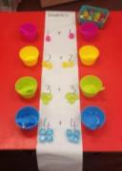
Recall number bonds to five and some number bonds to 10.  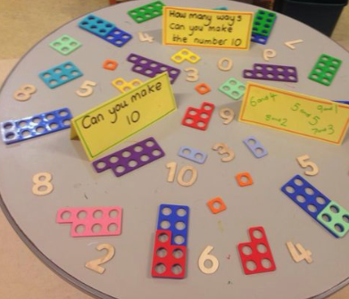 | Recall subtraction facts for numbers to five and some subtraction facts to 10.  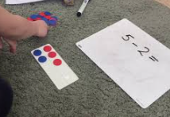 | Children understand how quantities can be distributed equally.  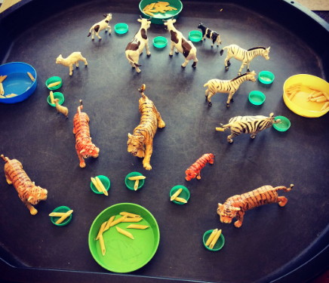

Addition

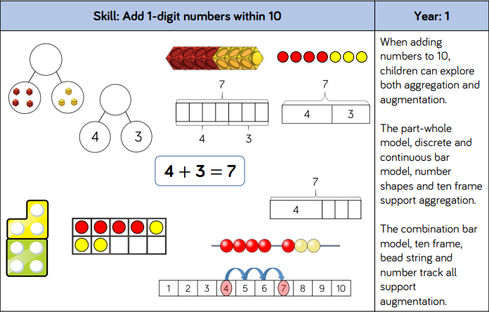

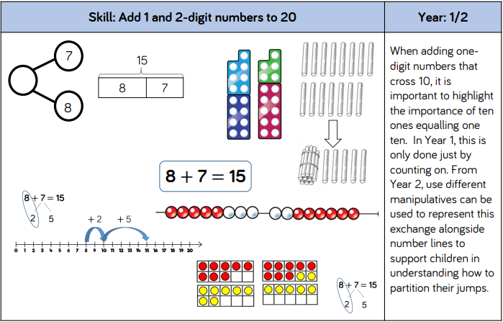

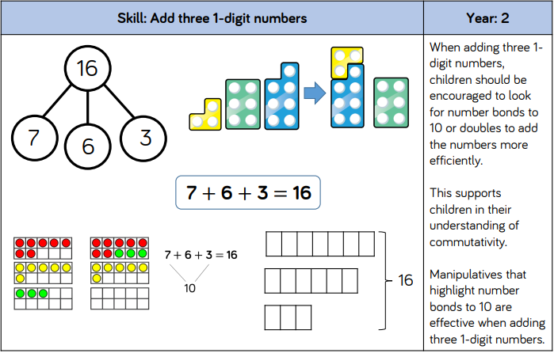

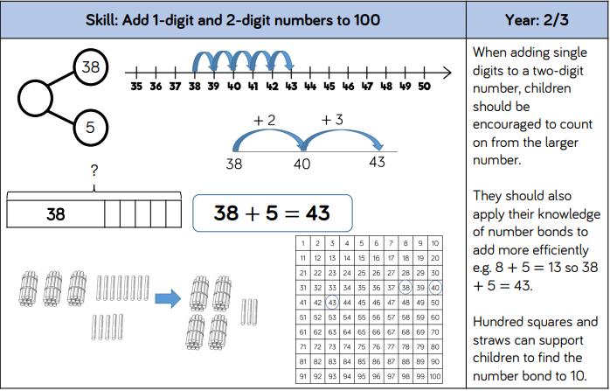

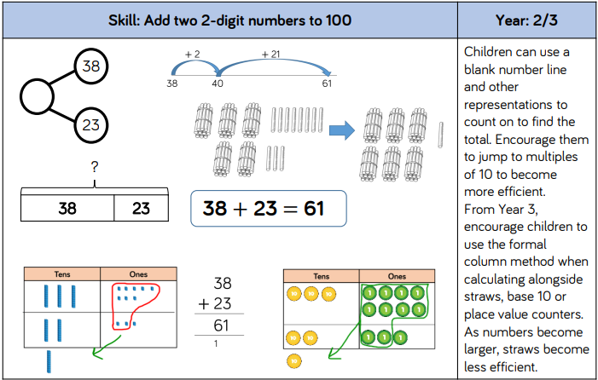

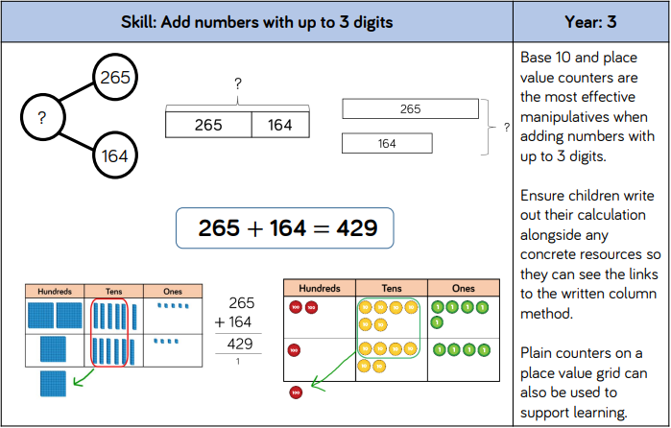

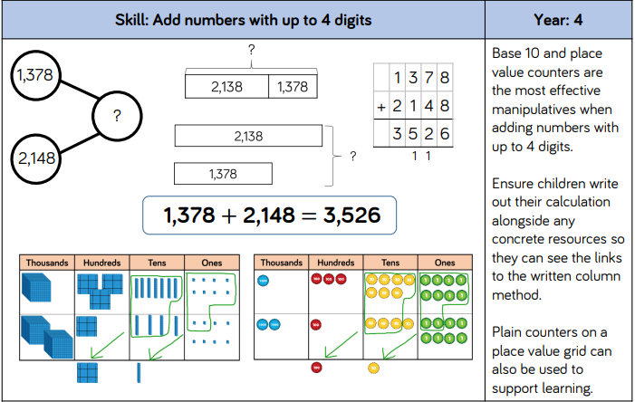

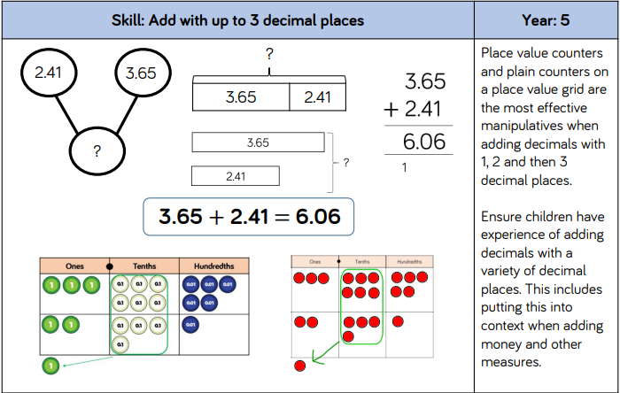

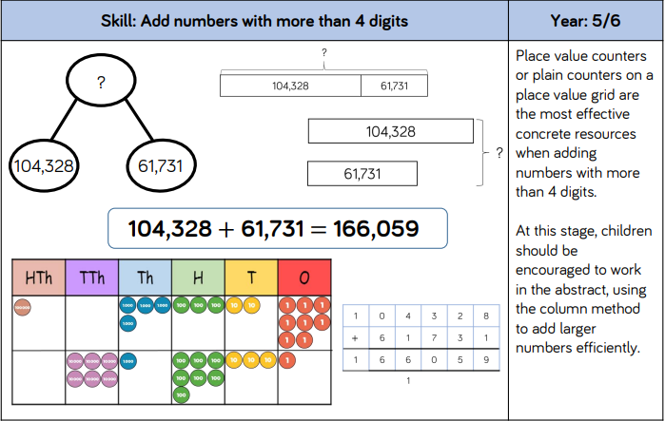

Subtraction
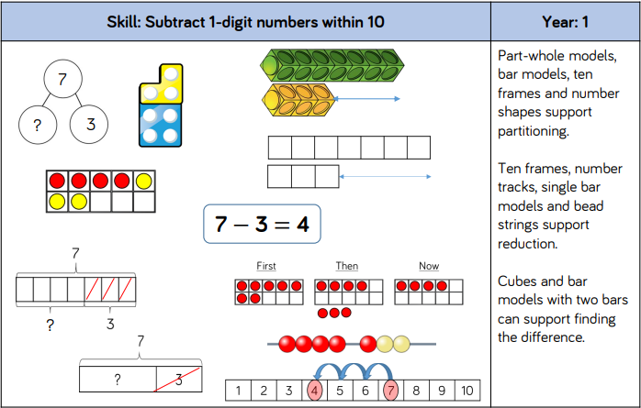

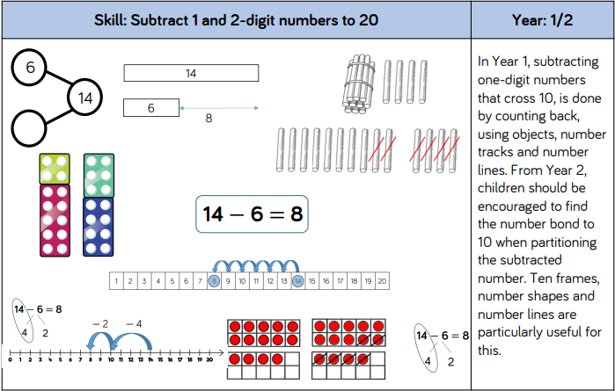

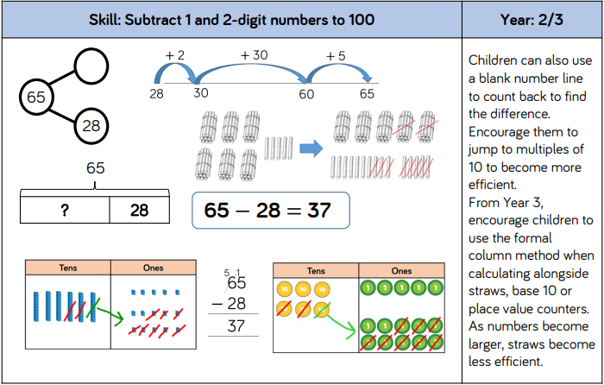

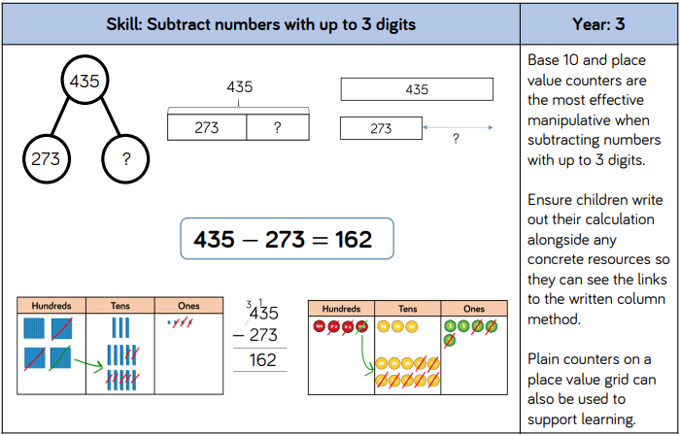

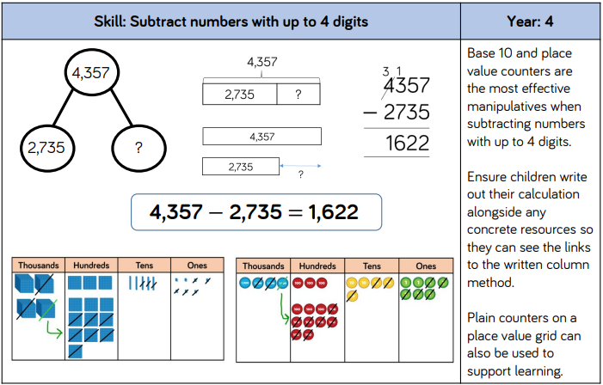

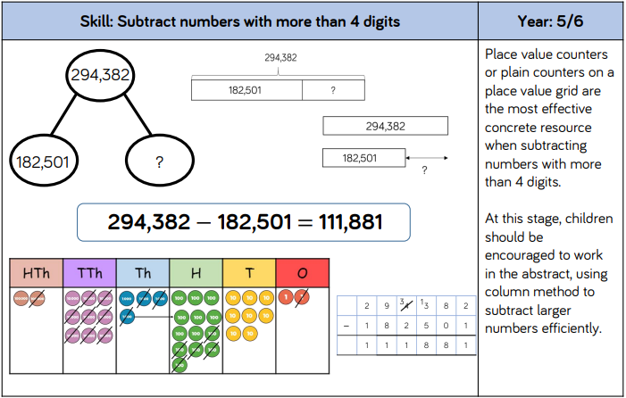

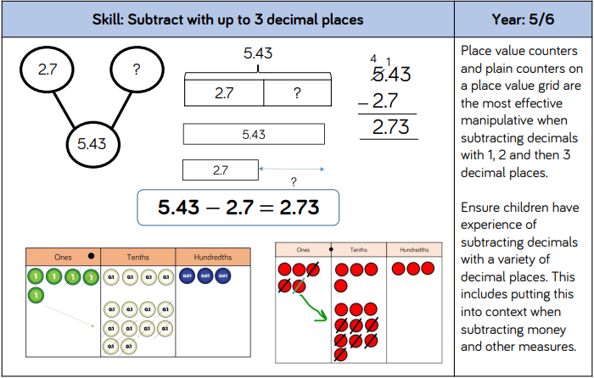

Multiplication (Times Tables)

The calculation policy for multiplication starts with an understanding of times tables; when they should be taught and what this teaching will look like.
In the Summer Term of Year 4, in line with the Government’s assessment framework, the children will sit the Multiplication Tables Check.
Times tables are then continued to be recalled and tested throughout Years 5 and 6 to further develop fluency.
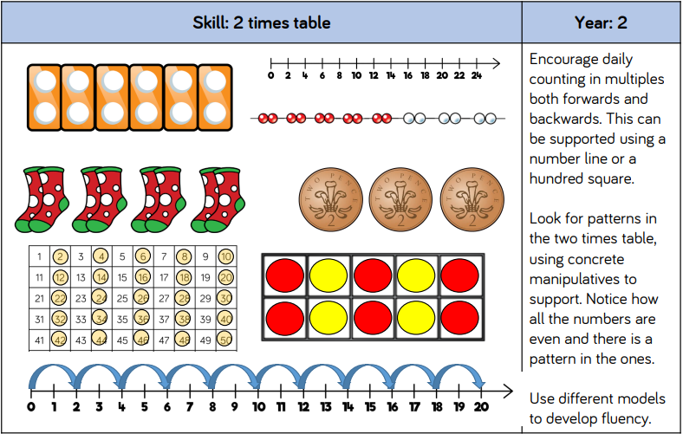

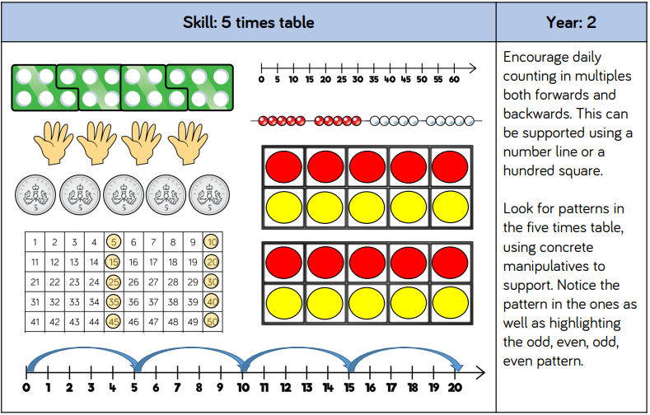

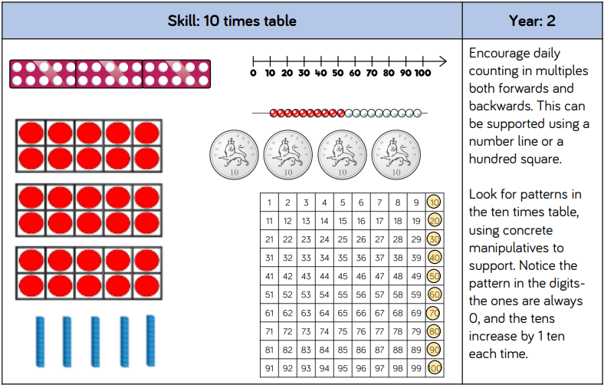

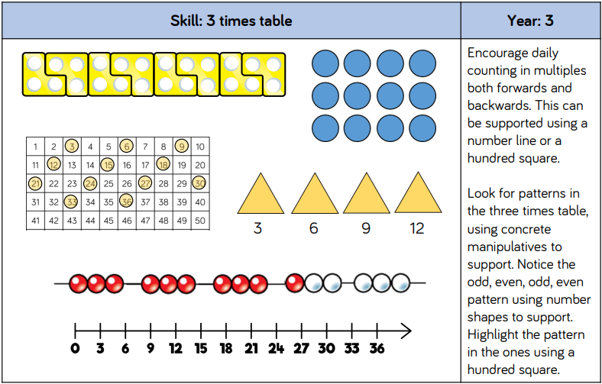

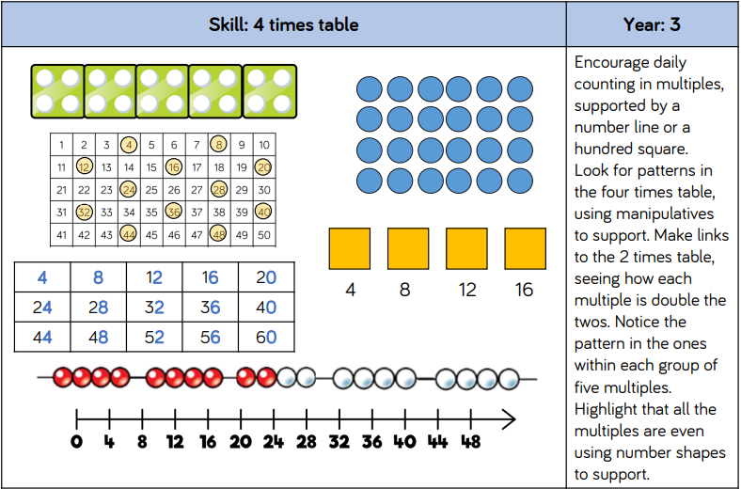

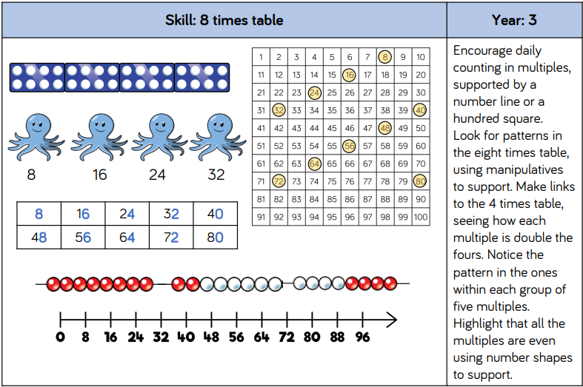

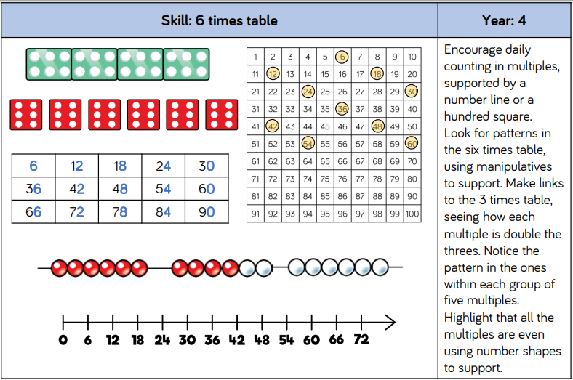

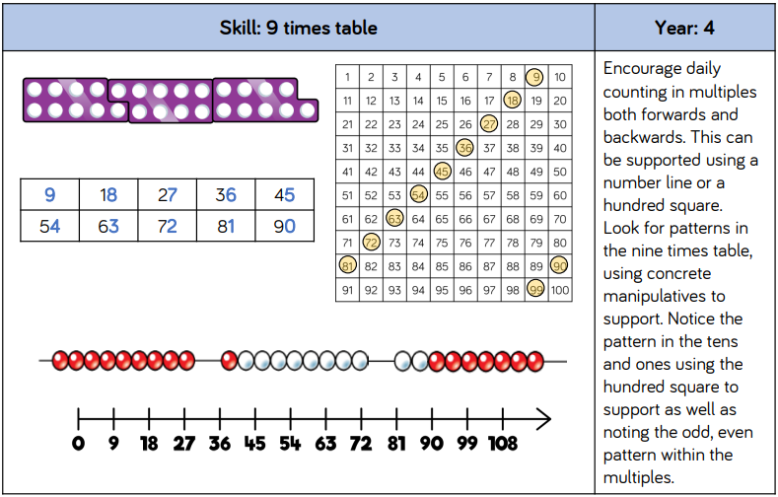

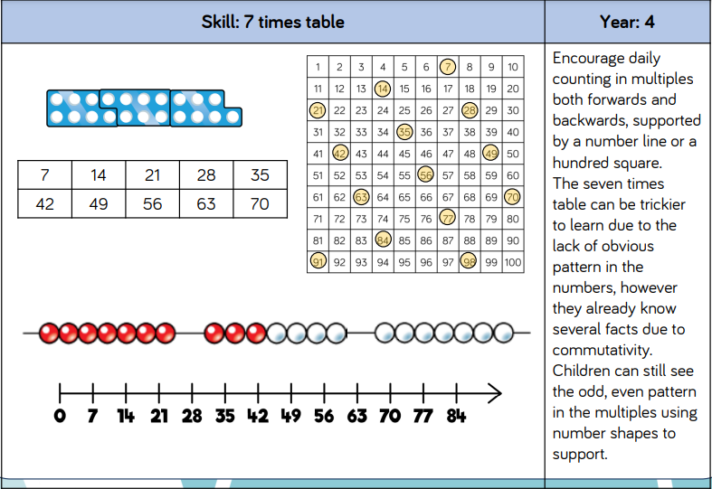

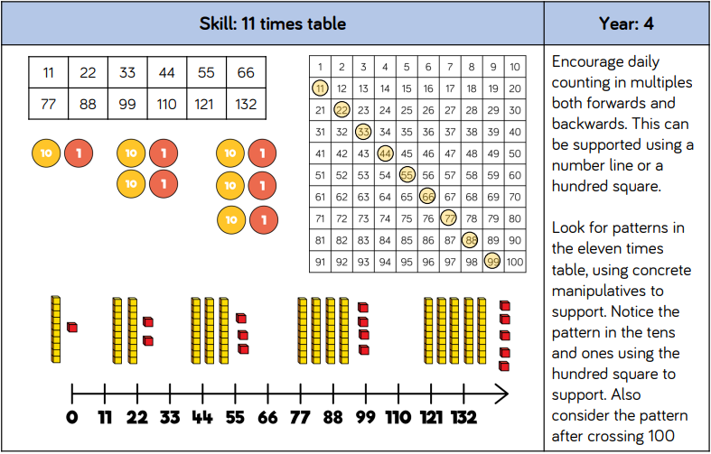

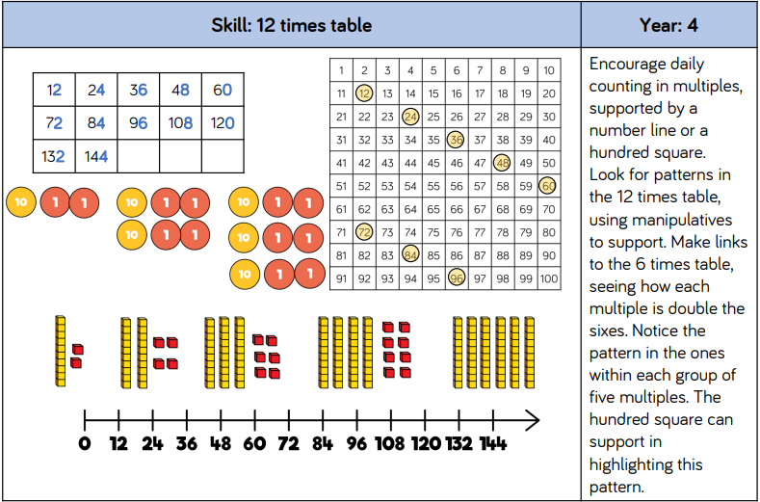

Multiplication (Calculations)

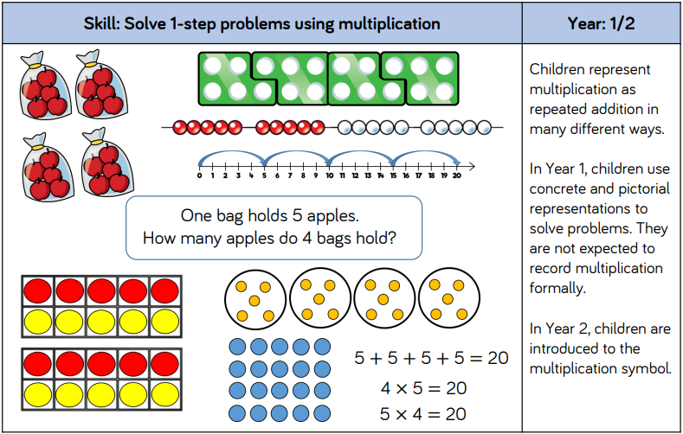

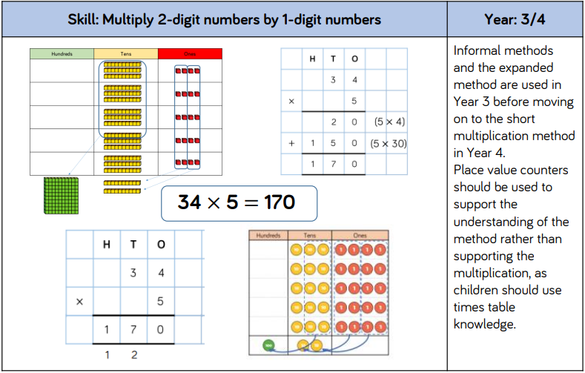

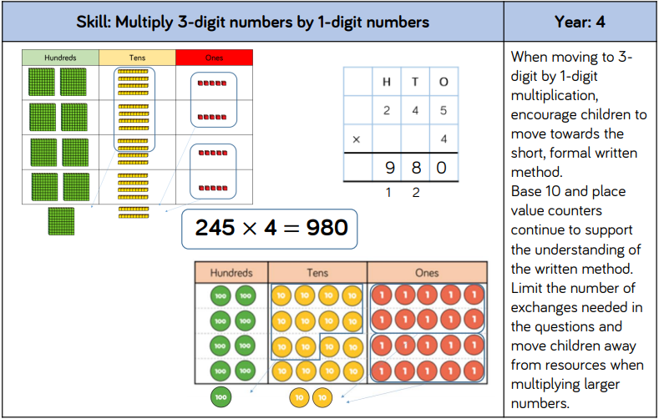

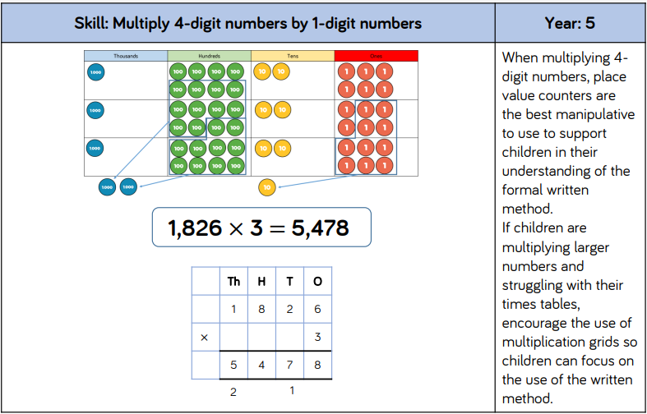

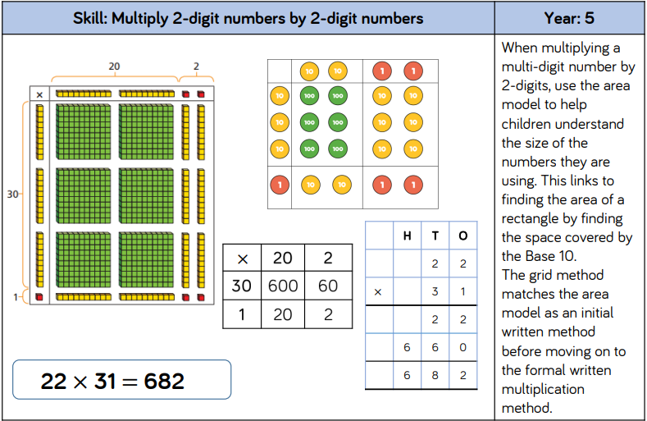

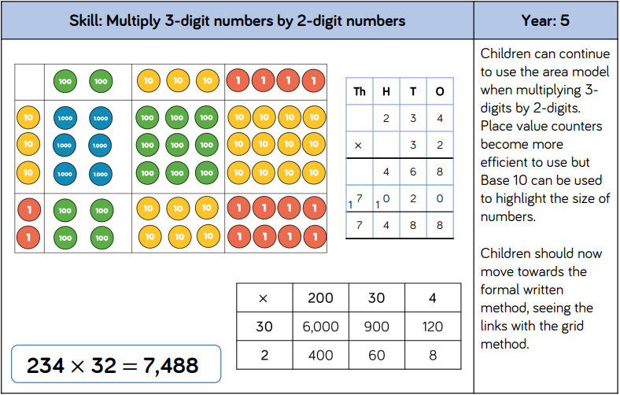

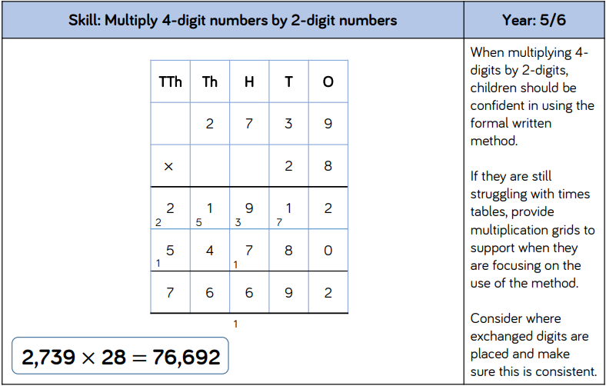

Division


