Jack’s Pre-School Long Term Maths Plan
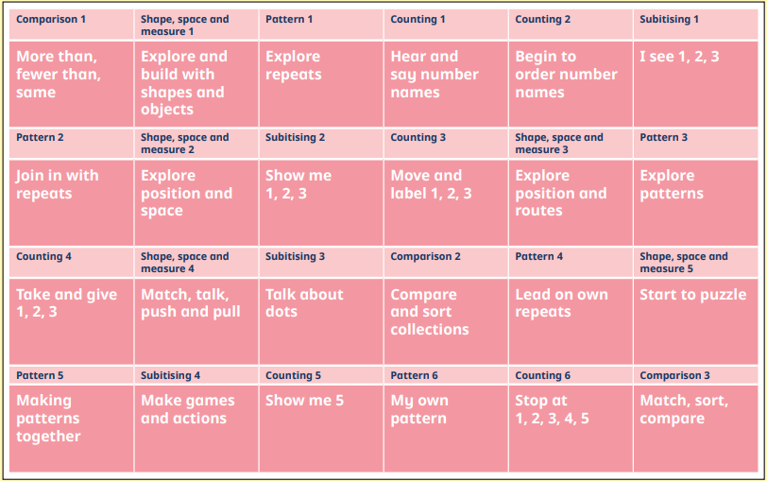
Key
Orange – Autumn
Green – Spring Term
Yellow – Summer Term

