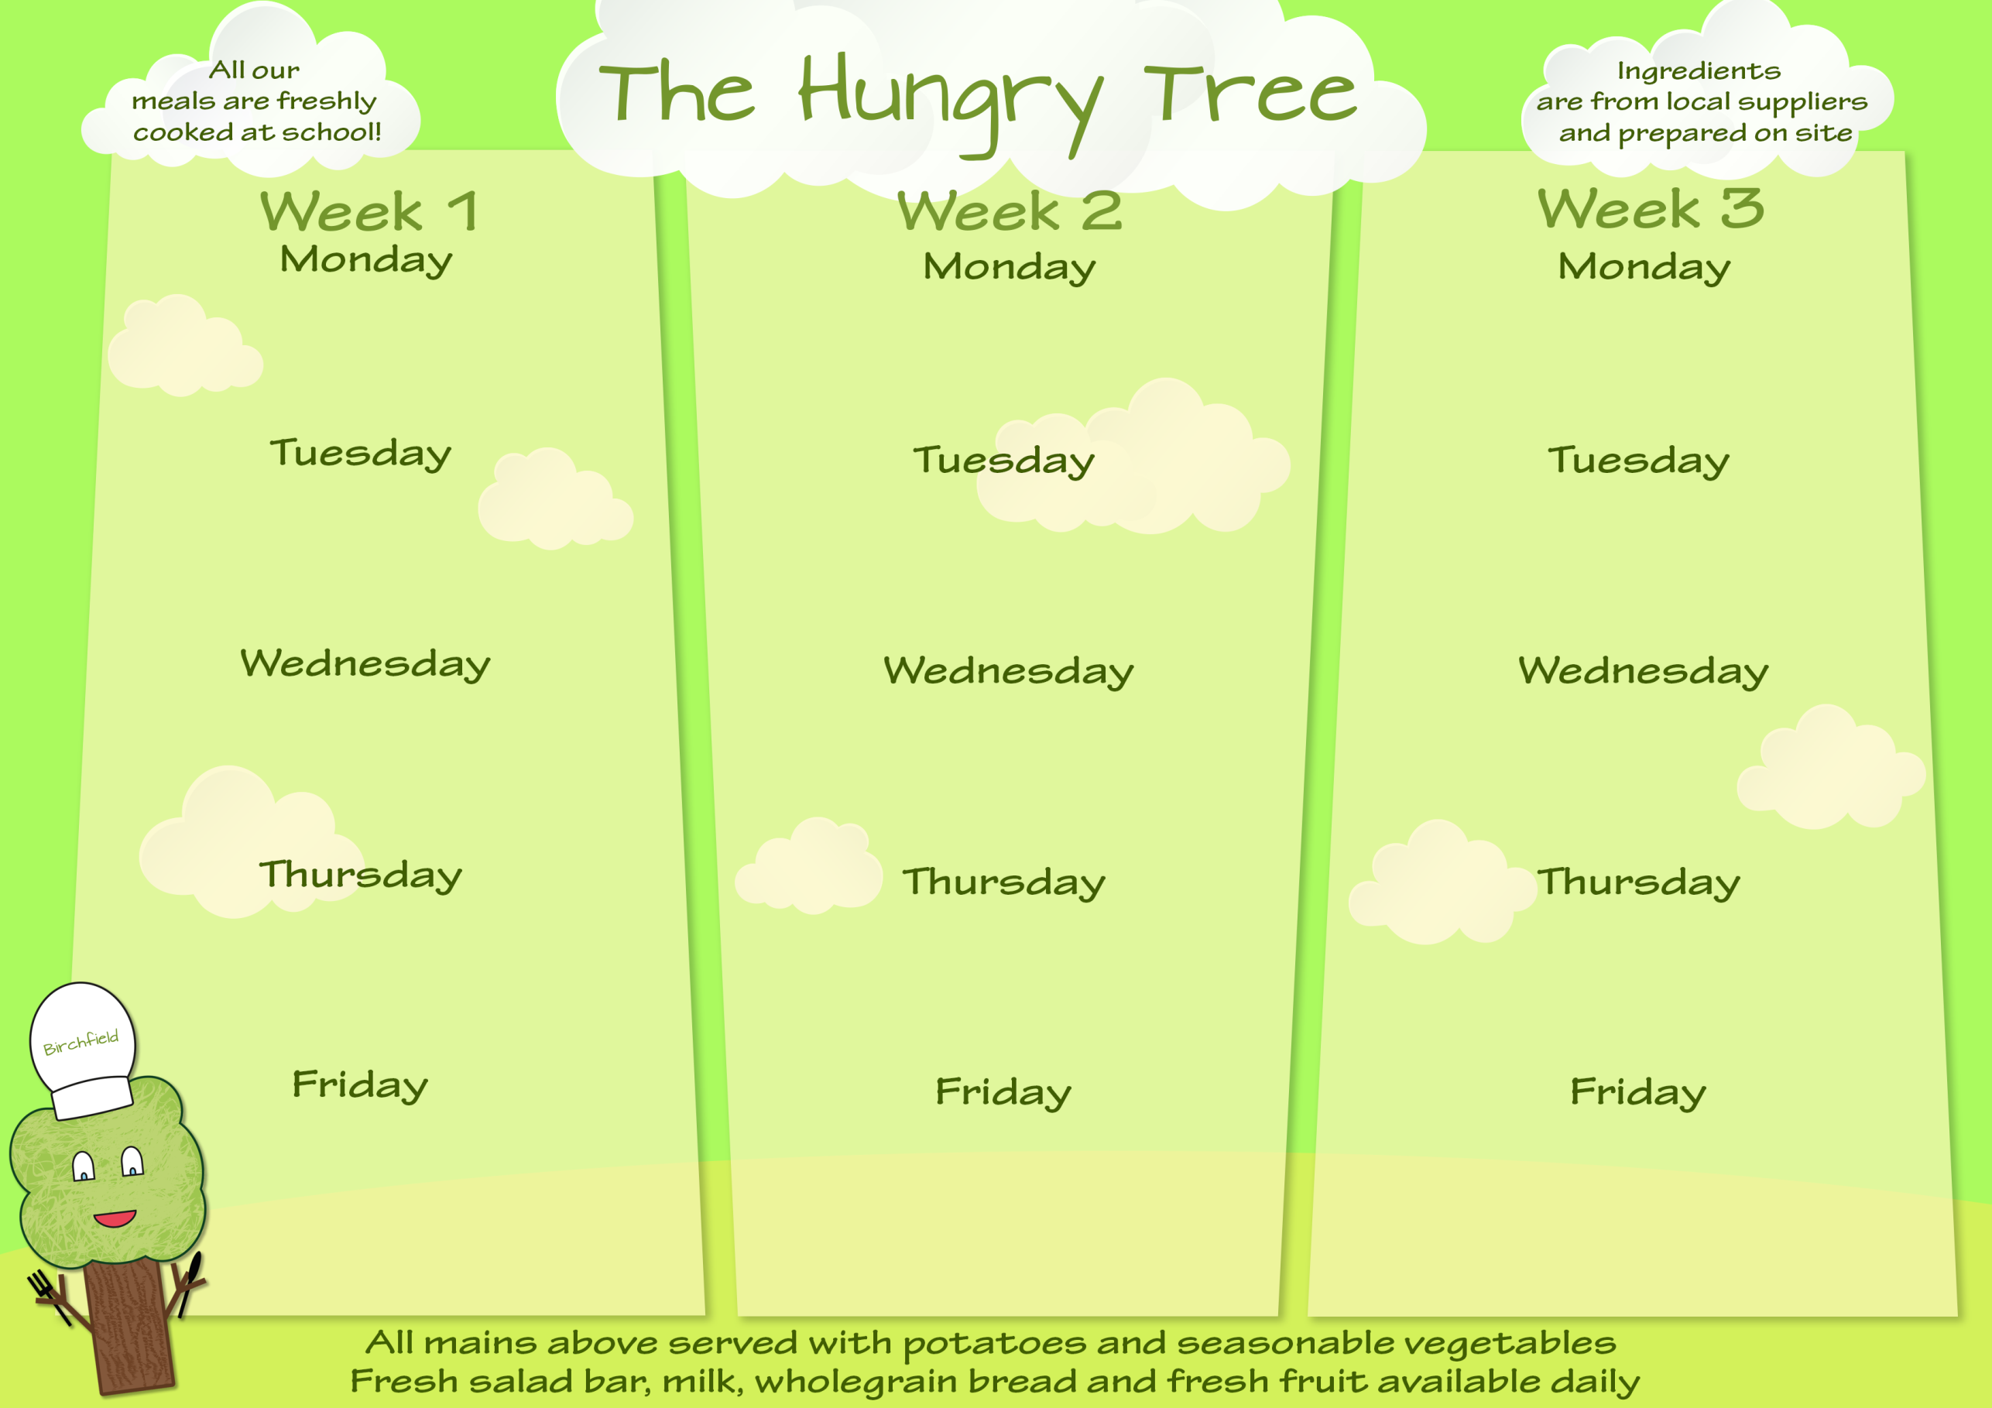
Margherita Pizza (M)(G)(S)(E) or Margherita Pizza (G)(M)(S)(E) or Jacket Potato Tuna Mayo (F)(E) or Ham Wrap (G)(M) and Chocolate Oat Cookie (G)(O)

Chicken Pie & Mash Potato (G)(M) or Cheese & Onion Potato Bake (M) or Jacket Potato Tuna Mayo (F)(E) or Cheese Bap (Ss)(G)(M) and Strawberry Flavoured Whip (M)

Salmon Fish Fingers & Chips (G)(F) or Falafel & Chips (G) or Jacket Potato & Beans or Ham Sandwich (G)(S) and Ice Cream (M)

Cheese & Tomato Pasta Bake (G)(M) or Cheese & Tomato Pasta Bake (G)(M) or Jacket Potato Tuna Mayo (E)(F) or Ham Sandwich (G)(S) and Sultana Flapjack (G)(O)

Chicken Roast Dinner or Oven Roasted Quinoa & Bean Stuffed Peppers or Jacket Potato Tuna Mayo (E)(F) or Cheese Wrap (M)(G) and Chocolate Flavoured Whip (M)

Beef Lasagne (G)(M) or Butternut Squash & Chickpea Risotto or Jacket Potato Cheese (M) or Tuna Mayo Sandwich (F)(G)(S)(E) and Fruit & Yogurt (M)

Quorn Sausage Hot Dog (Ss)(G) or Quorn Sausage Hot Dog (G)(Ss) or Jacket Potato Cheese (M) or Tuna Bap (F)(E)(G)(Ss) and Lemon Sponge & Custard (Sul)(G)(E)(M)

Creamy Cheese Pasta Bake (M)(G) or Creamy Cheese Pasta Bake (G)(M) or Jacket Potato Tuna Mayo (F)(E) or Cheese Sandwich (M)(G)(S) and Chocolate Brownie (G)(E)

Chicken Curry & Rice (M) or Chickpea Curry & Rice or Jacket Potato Cheese (M) or Cheese Sandwich (G)(S)(M) and Apple Crumble & Ice Cream (G)(M)

Chicken Roast Dinner or Vegetable & Lentil Hotpot (M) or Jacket Potato Cheese (M) or Tuna Mayo Sandwich (G)(F)(S)(E) and Fruit & Yogurt (M)

Fish & Chips (G)(F) or Quorn Nuggets & Chips (G) or Jacket Potato & Beans or Ham Wrap (G) and Cheese & Crackers (G)(M)

Chicken Roast Dinner or Quorn Fillet Roast Dinner (G) or Jacket Potato Tuna Mayo (F)(E) or Cheese Wrap (M)(G) and Fruit & Yogurt (M)

Mild Mixed Bean Chilli Burrito (G) or Mild Mixed Bean Chilli Burrito (G) or Jacket Potato Cheese (M) or Tuna Mayo Bap (G)(Ss)(F)(E) and Bananas & Custard (M)

Sweet & Sour Chicken & Rice (S) or Sweet & Sour Vegetables & Lentils & Rice (S) or Jacket Potato Cheese (M) or Tuna Sandwich (F)(E)(G)(S) and Caramel Flavoured Whip (M)

Fish Fingers & Chips (G)(F) or Vegetable Burger & Chips (G) or Jacket Potato & Beans or Cheese Bap (G)(M)(Ss) and Fruit & Ice Cream (M)

Fresh Fruit & Wholemeal Bread Available Daily
W/B 4th May, 1st June, 22nd June, 13th July

W/B 27th Apr, 18th May, 15th June, 6th July

W/B 20th Apr, 11th May, 8th Jun, 29th Jun, 20th Jul

Allergens: Contains (N) Nuts; (P) Peanuts; (M) Milk; (S) Soya; (Mus) Mustard; (L) Lupin; (E) Eggs; (F) Fish; (SF) Shellfish; (G) Gluten; (SS) Sesame Seeds; (C) Celery; (Sul) Sulphur Dioxide or Sulphites; (Cru) Crustaceans; (Mol) Molluscs; (O)Oats

All Hot Meals Are Served With A Selection Of Vegetables
All Hot Meals Are Served With A Selection Of Vegetables

