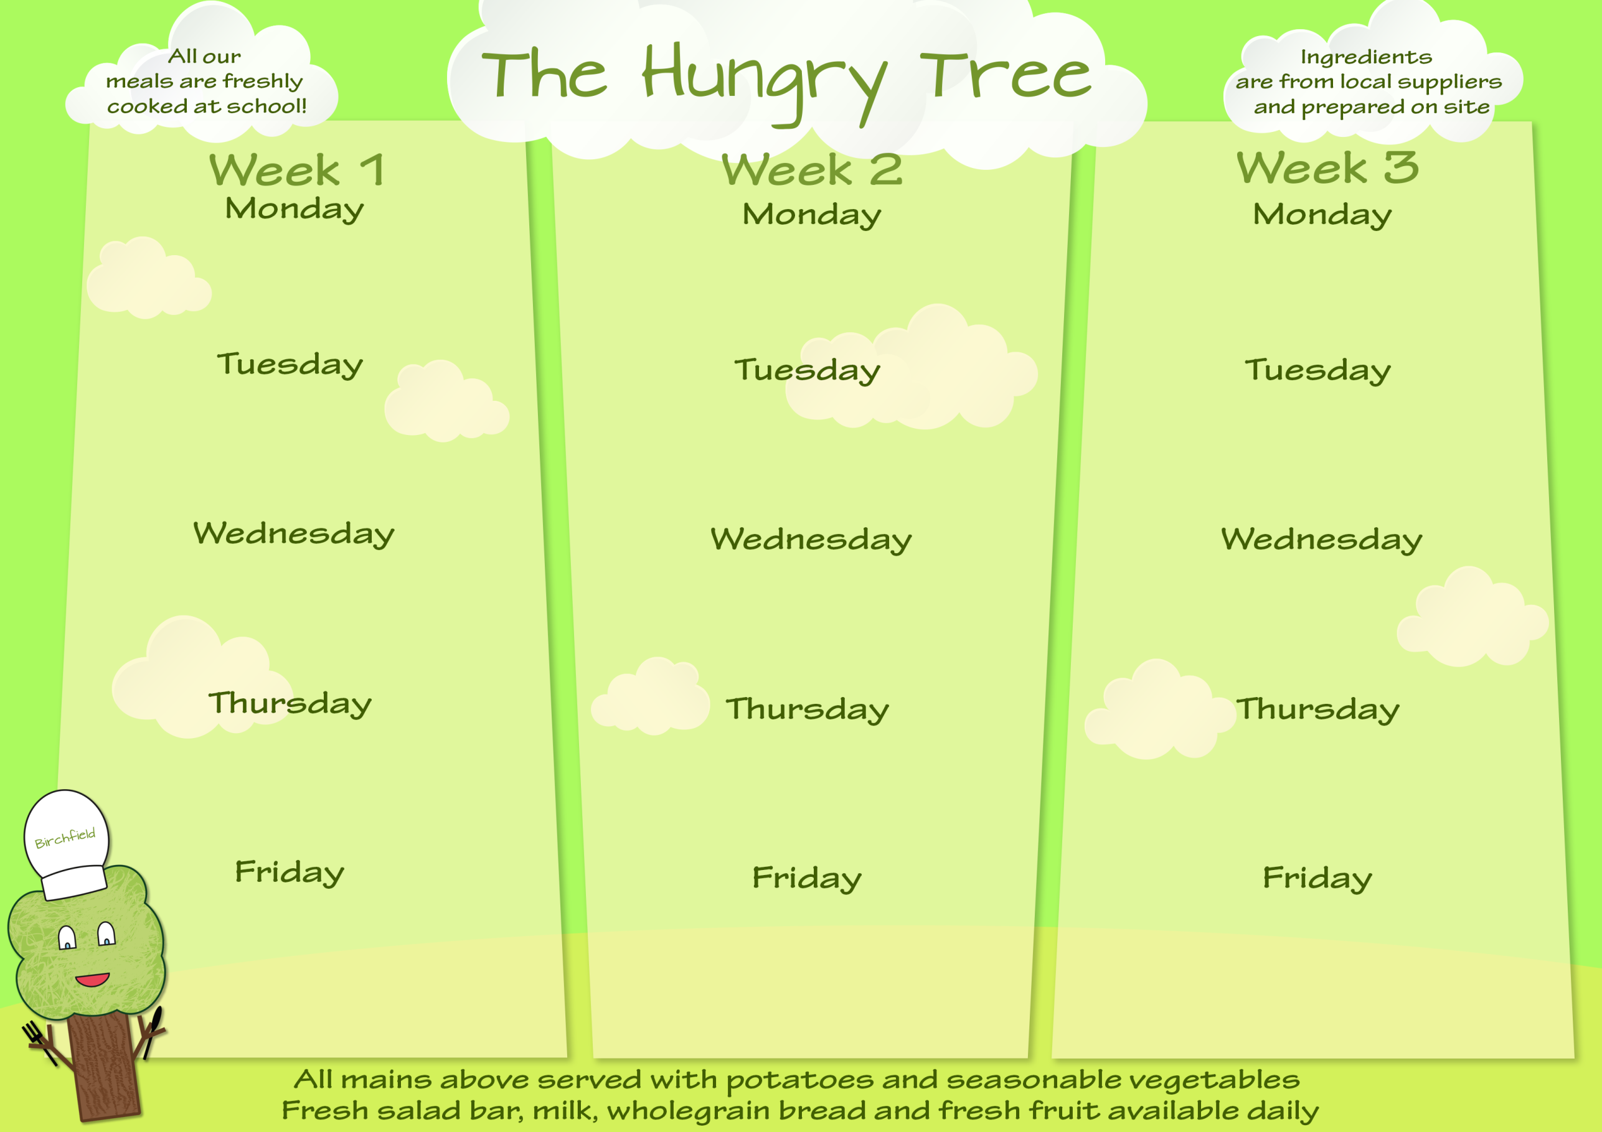
nd
Fish Fingers & Chips (F)
And
Ice Cream (S)
Butternut Squash & Chickpea Risotto
And
Fruit & Vanilla Dessert (S)

W/B 4th May, 1st Jun, 22nd Jun, 13th Jul

W/B 27th Apr, 18th May, 15th Jun, 6th Jul

W/B 20th April, 11th May,8th Jun, 29th Jun, 20th Jul

All Hot Meals Are Served With A Selection Of Vegetables
SPECIAL DIET
All Special Diet Meals Are Gluten & Dairy Free
Tomato Pasta (S)
And
Shortbread (S)
Jacket Potato & Beans
And
Fruit & Ice Cream (S)

Bolognaise & Rice
And
Lemon Sponge (S)

Chicken Roast Dinner
And
Jelly Pot

Fish & Chips (F)
And
Ice Cream (S)
Ham & Mushroom Pizza (S)
And
Vanilla Dessert (S)
Chicken Roast Dinner
And
Jelly Pot
Chicken Hot Pot
And
Chocolate Biscuit (S)

Chickpea Curry & Rice
And
Fruit Crumble & Ice Cream (S)

Mild Mixed Bean Chilli & Pasta (S)
And
Banana & Chocolate Dessert (S)
Jacket Potato & Ham
And
Chocolate Sponge (S)
Sweet & Sour Chicken & Rice (S)
And
Vanilla Dessert (S)
Chicken Roast Dinner
And
Fruit & Ice Cream (S)
Allergens: Contains (N) Nuts;(P) Peanuts; (M) Milk; (S) Soya; (Mus) Mustard; (L) Lupin; (E) Eggs; (F) Fish; (SF) Shellfish; (G) Gluten; (SS) Sesame Seeds; (C) Celery; (Sul) Sulphur Dioxide or Sulphites;(Cru) Crustaceans; (Mol) Molluscs

